**Building a DevSecOps Pipeline with Open-Source Tools**

**A tutorial on how to build a DevSecOps pipeline with open-source tools.**

1. ***Introduction to DevSecOps***
2. ***List of Top Open-Source Tools***
3. ***Case Studies and Real-world Examples with sample code***
4. ***Best Practices for Building a DevSecOps Pipeline***
5. ***Advanced Techniques for DevSecOps Pipeline***
6. ***Conclusion***

**Introduction to DevSecOps**

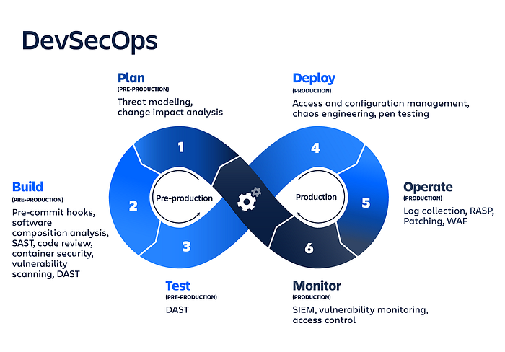

**Overview of Open-Source Tools**

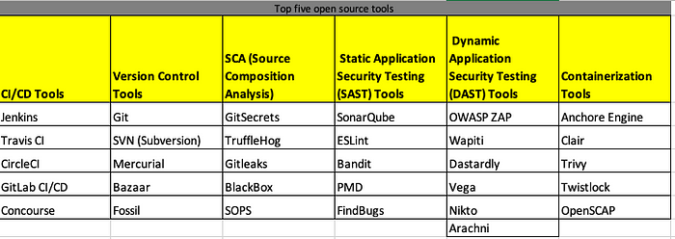

Various Open source tool for DevSecOps

1. **CI/CD Tools:**

Jenkins, Travis CI, CircleCI, GitLab CI/CD, Concourse

2. **Version Control Tools**

Git, SVN (Subversion), Mercurial, Bazaar, Fossil

3. **Secret Scanning Tools**

GitSecrets, TruffleHog, Gitleaks, BlackBox, SOPS

4. **SCA (Source Composition Analysis)**

OWASP Dependency-Check, WhiteSource Bolt, OpenSCA, Black Duck Hub, CycloneDX

3. **Static Application Security Testing (SAST) Tools**

SonarQube, Snyk, Semgrep, Bandit, FindBugs

4. **Dynamic Application Security Testing (DAST) Tools**

OWASP ZAP, Wapiti, Dastardly, Vega, Nikto, Arachni

5. **Containerization Tools**

Anchore Engine, Clair, Trivy, Twistlock, OpenSCAP

**Case Studies and Real-World Examples with Sample Code**

Creating a detailed step-by-step DevSecOps pipeline with code for Vaidu Tech (Alias) One would require access to their specific pipeline implementation, which is proprietary and not publicly available. However, I can provide you with a general outline of the steps involved in building a DevSecOps pipeline and the essential components typically included. You can use this as a starting point and customize it based on your specific requirements. Here’s a high-level overview:

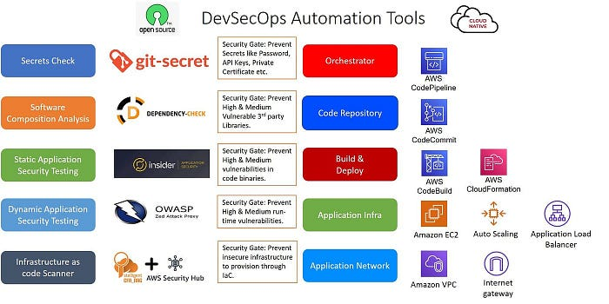

DevSecOps Automation tools

**Step 1: Requirement Gathering and Planning:**

* Identify security requirements and compliance standards specific to your project and industry.
* Define the scope and goals of your DevSecOps pipeline.
* Establish the key stakeholders and teams involved, including development, operations, and security.

**Step 2: Infrastructure Setup:**

* Set up your development and production environments, leveraging infrastructure-as-code tools like Terraform, AWS CloudFormation, or Azure Resource Manager Templates.
* Ensure that the infrastructure is securely provisioned and configured, following industry best practices and security guidelines.

// main.tf  
provider "aws" {  
 region = "us-west-2"  
}

resource "aws_instance" "web" {  
 ami = "ami-0c94855ba95c71c99"  
 instance_type = "t2.micro"  
}resource "aws_security_group" "web" {  
 name = "web_sg"  
 description = "Security group for web instances" ingress {  
 from_port = 80  
 to_port = 80  
 protocol = "tcp"  
 cidr_blocks = ["0.0.0.0/0"]  
 }  
}output "instance_ip" {  
 value = aws_instance.web.public_ip  
}

**Step 3: Version Control and Collaboration:**

* Utilize a version control system like Git to manage your codebase securely.
* Establish a collaborative workflow, enabling developers to work together and manage code changes effectively.

**Step 4: Continuous Integration (CI):**

* Set up a CI server like Jenkins or GitLab CI/CD to automate the building, testing, and packaging of your application code.
* Configure the CI server to trigger builds automatically whenever code changes are committed.

pipeline {  
 agent any

stages {  
 stage('Build') {  
 steps {  
 sh 'mvn clean package'  
 }  
 } stage('Unit Tests') {  
 steps {  
 sh 'mvn test'  
 }  
 }  
 }  
}

**Step 5: Static Code Analysis and Security Testing:**

* Integrate static code analysis tools such as SonarQube or Checkmarx into your CI pipeline to identify code quality issues, bugs, and security vulnerabilities.
* Configure the tools to enforce security policies, coding standards, and secure coding practices.

<!-- pom.xml -->  
<build>  
 <plugins>  
 <plugin>  
 <groupId>org.sonarsource.scanner.maven</groupId>  
 <artifactId>sonar-maven-plugin</artifactId>  
 <version>3.9.1.2184</version>  
 </plugin>  
 </plugins>  
</build>

**Step 6: Dependency Management and Software Composition Analysis (SCA):**

* Utilize dependency management tools like Maven or npm to manage and track external libraries and dependencies.
* Incorporate a Software Composition Analysis (SCA) tool like Black Duck, OWASP Dependency-Check, or Snyk to identify and remediate vulnerabilities in third-party components

<!-- pom.xml -->  
<build>  
 <plugins>  
 <plugin>  
 <groupId>org.owasp</groupId>  
 <artifactId>dependency-check-maven</artifactId>  
 <version>6.0.2</version>  
 <executions>  
 <execution>  
 <goals>  
 <goal>check</goal>  
 </goals>  
 </execution>  
 </executions>  
 </plugin>  
 </plugins>  
</build>

**Step 7: Dynamic Application Security Testing (DAST):**

* Integrate a DAST tool like OWASP ZAP, Burp Suite, or Netsparker into your pipeline to simulate real-world attacks and identify security vulnerabilities in your application.
* Automate DAST scans as part of your CI pipeline or as scheduled tests during the development process.

**Step 8: Containerization and Container Security:**

* Implement containerization using Docker or Kubernetes to package and deploy your applications consistently across environments.
* Include container security practices such as image vulnerability scanning, runtime security monitoring, and secure container configuration using tools like Docker Security Scanning or Clair.

# Dockerfile  
FROM openjdk:11-jdk

WORKDIR /appCOPY target/my-app.jar /app/my-app.jarEXPOSE 8080CMD ["java", "-jar", "my-app.jar"]

**Step 9: Continuous Deployment (CD):**

* Automate the deployment process using deployment tools like Ansible, Chef, or Kubernetes for seamless and repeatable deployments.
* Implement deployment strategies like blue/green deployments or canary releases to minimize risks and ensure smooth rollbacks if necessary.

# deploy.sh  
#!/bin/bash

kubectl apply -f deployment.yaml

**Step 10: Continuous Monitoring and Incident Response:**

* Integrate a centralized logging and monitoring solution like ELK Stack (Elasticsearch, Logstash, Kibana), Splunk, or Prometheus to collect and analyze logs and metrics from your applications and infrastructure.
* Implement real-time alerting mechanisms to notify the appropriate teams in case of security events or anomalies.

**Step 11: Compliance and Governance:**

* Implement compliance checks and audits within your pipeline to ensure adherence to regulatory requirements and security standards.
* Utilize tools like OpenSCAP or Chef Compliance to perform automated compliance scans and generate reports.

# compliance.sh  
#!/bin/bash

oscap xccdf eval --profile server /usr/share/xml/scap/ssg/content/ssg-rhel7-ds.xml

Please note that these code examples are simplified and may need to be adapted to fit your specific requirements and tools. They serve as a starting point to give you an idea of how the different components of a DevSecOps pipeline can be implemented. It’s important to customize and modify the code snippets to align with your specific technologies, infrastructure, and security requirements.

Additionally, remember that building a DevSecOps pipeline involves configuring various tools, integrating them into your pipeline, and establishing the necessary processes and workflows. The code snippets provided above represent just a portion of the overall implementation.

To build a complete and robust DevSecOps pipeline similar to Vaidik Tech’s implementation, please provide me with the tools selection and I will try to provide you all step by step code snippet for the same.

**Best Practices for Building a DevSecOps Pipeline**

To build an effective DevSecOps pipeline, consider the following best practices:

1. **Security as Code**: Treat security configurations, policies, and controls as code and manage them using version control systems to ensure consistency and repeatability.
2. **Automation**: Leverage automation tools to enforce security checks and policies throughout the pipeline, reducing human error and increasing efficiency.
3. **Collaboration**: Foster collaboration and communication between development, operations, and security teams to share knowledge, identify risks, and resolve issues promptly.
4. **Continuous Feedback**: Establish feedback loops to provide developers with actionable security information and encourage a culture of continuous improvement.
5. **Threat Modeling**: Conduct threat modeling exercises to identify potential security risks and design appropriate security controls early in the development process.
6. **Security Testing**: Implement a variety of security testing techniques, such as static code analysis, dynamic application security testing (DAST), and penetration testing, to identify and remediate vulnerabilities.
7. **Secure Configurations**: Ensure that all components, such as servers, containers, and databases, are securely configured based on industry best practices and hardened against known vulnerabilities.

**Advanced Techniques for DevSecOps Pipeline**

1. **Infrastructure as Code (IaC) Security**: Implement security checks and validations within the infrastructure code to ensure secure provisioning and configuration of cloud resources. Tools like Terraform, AWS CloudFormation, and Azure Resource Manager Templates can be used to define and manage infrastructure securely.
2. **Container Security**: Enhance container security by incorporating techniques such as image vulnerability scanning, container runtime security, and secure container orchestration. Tools like Docker Security Scanning, Clair, and Kubernetes Security Contexts can be used to strengthen container security.
3. **Security Orchestration, Automation, and Response (SOAR)**: Integrate SOAR platforms to automate security incident response processes. These platforms help orchestrate security workflows, enable automated threat response, and facilitate collaboration between security teams and development/operations teams.
4. **Security Testing in Production**: Implement techniques such as canary deployments and blue/green deployments to test application security in a production-like environment. By gradually exposing new releases to a subset of users, security vulnerabilities can be identified and addressed before a full release.
5. **Threat Intelligence Integration**: Integrate threat intelligence feeds into security monitoring systems to enhance detection and response capabilities. This allows for proactive identification of emerging threats and prompt actions to mitigate potential risks.
6. **Immutable Infrastructure**: Build and deploy immutable infrastructure where instances or containers are never modified after deployment. This approach ensures that any changes or vulnerabilities are resolved by creating new instances or containers, reducing the risk of compromise due to configuration drift or unpatched software.
7. **Secure Supply Chain Management**: Implement secure software supply chain practices, including verifying the integrity and authenticity of third-party libraries and dependencies, using code signing, and monitoring for any potential supply chain attacks

**Conclusion**

DevSecOps is a crucial approach for ensuring that security is integrated throughout the software development lifecycle. By adopting DevSecOps practices, organizations can build secure and resilient applications while maintaining the agility and speed of DevOps. Leveraging open-source tools, setting up an effective DevSecOps pipeline, and implementing advanced techniques will help organizations stay ahead of security threats and deliver secure software in a rapidly evolving landscape.